42.26: a) From Eq. (42.22), 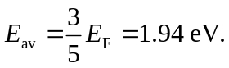
b) 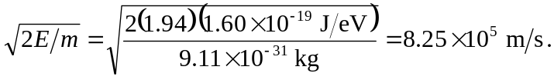
c) 